Data Model
The Chinook data model represents a digital media store, including tables for artists, albums, media tracks, invoices and customers.

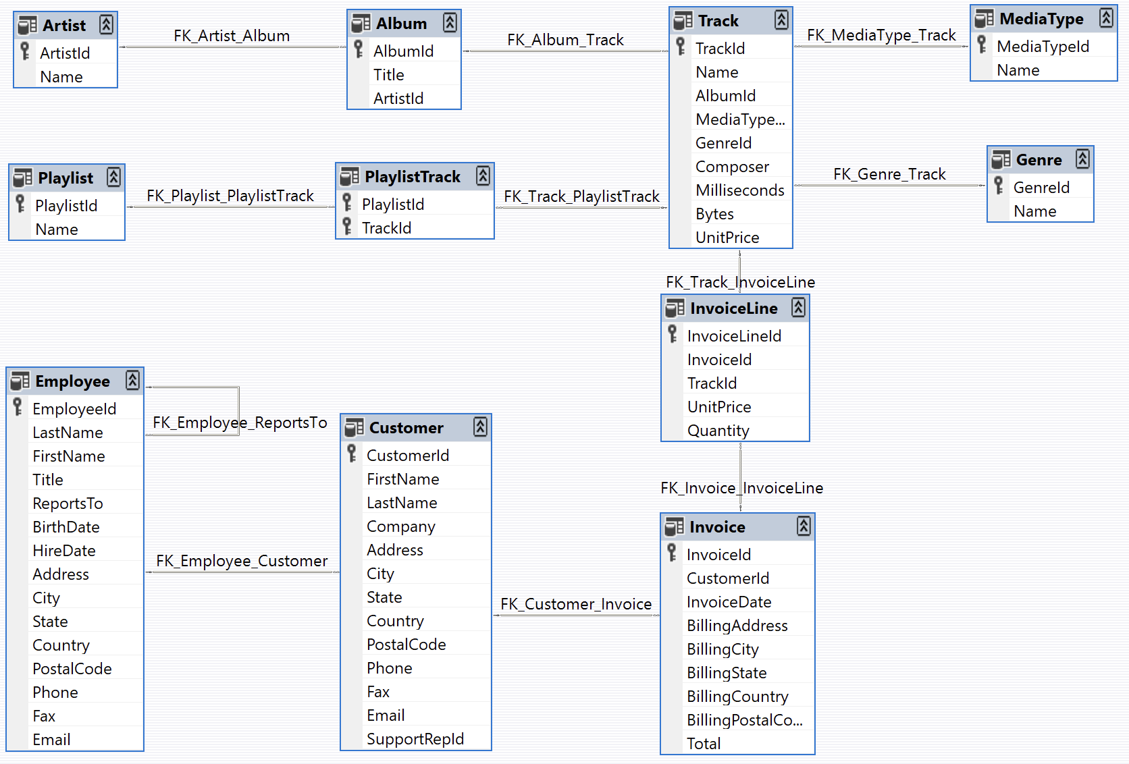

Sample Data
Media related data was created using real data from an iTunes Library. Customer and employee information was manually created using fictitious names, addresses that can be located on Google maps, and other well formatted data (phone, fax, email, etc.). Sales information is auto generated using random data for a four year period.

Why the name Chinook?
The name of this sample database was based on the Northwind database. Chinooks are winds in the interior West of North America, where the Canadian Prairies and Great Plains meet various mountain ranges. Chinooks are most prevalent over southern Alberta in Canada. Chinook is a good name choice for a database that intents to be an alternative to Northwind.

